Connected Workgroups on a Single Server
By Doug Redmond

Introduction:
This document explains how to create a replicated Vault environment on a single server machine.

This configuration is for testing purposes only. There is no practical reason you would want to replicate on the same computer. Some of the techniques in this document are not supported by Autodesk.

It’s recommended to run these steps on a virtual server. That way, when you have everything running properly, you can save the image for later use. I also recommend having the license server on a separate machine.

Installing SQL Servers:
- Install a full version of SQL Server. I’ll be using SQL Server 2008 Standard Edition in this example.
  - Make sure to enable the Replication feature (figure 1).
  - Make sure to install the SQL Management tools.
  - Use AUTODESKVAULT as the instance name.
  - Set the SQL Agent service to startup automatically.
  - Make sure to install with mixed mode authentication.
- Install another full version of SQL Server.
  - Make sure to enable the Replication feature (figure 1).
  - Choose another name for the instance. I’ll just be using the default instance name for this example.
  - Set the SQL Agent service to startup automatically.
  - Make sure to install with mixed mode authentication.
- Upgrade instances to at least SP 1.
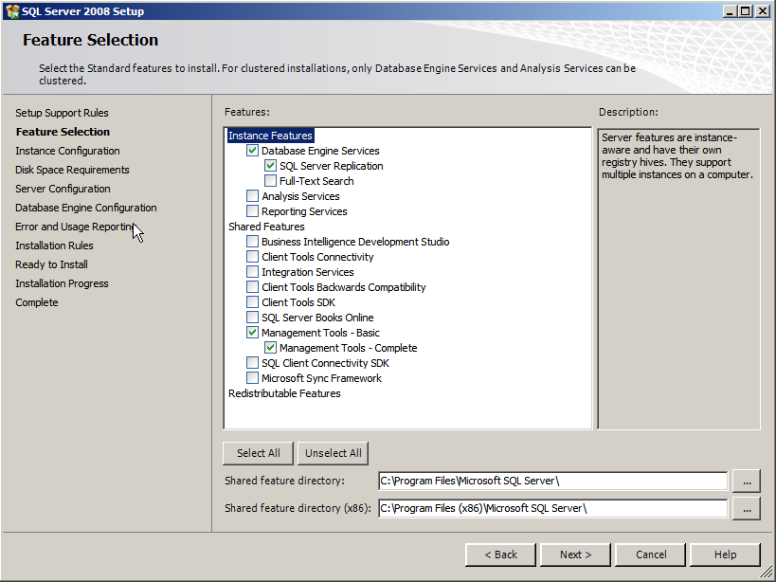
Figure 1

Validation:
Open up the Services dialog under Administrative Tools. You should see at least 4 SQL Services: A SQL Server and SQL Server Agent entry for each instance.
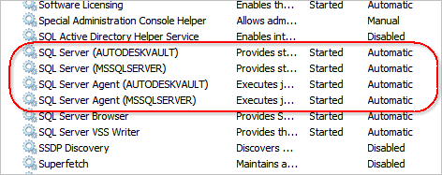

Installing Vault Server:
- Run the Vault server install. For this example, I will use Vault Professional 2011.
- Click on the Configure button on the Begin Installation page.
- Set the license server location.
- It should detect the AUTODESKVAULT instance of SQL Server. Input the ‘sa’ password.
- Complete the configuration.
- Click the Install button.
- You’ll see a message about an existing database detected, but you can ignore it since you have a fresh SQL Install.
- Once the install is completed it will require you to run the ADMS console.
- Exit ADMS console.
Installing Vault Client:
- Run the Vault client install.

Validation:
Open up the Vault Explorer client to make sure things work. Add a file. Test out any other features if you want.
Exit Vault Explorer.

Setting up the second web site:
Now we are getting into the unsupported/hacking steps. The basic idea here is to create another website for running ADMS. It will have a different name and port, and code base, but all the other settings will be the same.
- Create a copy of your entire ADMS folder. Give it a name like ‘ADMS Professional 2011 - Site B’
- Open the IIS Manager. In this example, I am using IIS 7.
- Add a new Web Site.
  - Give the site a name. ‘Site B’ is what I will use in this example.
  - Set the Application pool to Classic .NET.
  - Choose a port other than 80. I’ll use 2112 for this example.
  - Set the physical path to a new folder. It doesn’t matter where since we don’t do anything with it.
  - Click OK to create the site.
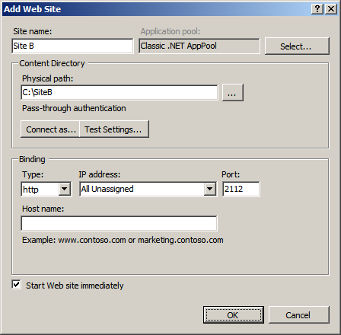
- Right-click on the Services folder and select ‘Add Virtual Directory’
  - AutodeskDM should be the alias and your copied Server\Web folder should be the path.
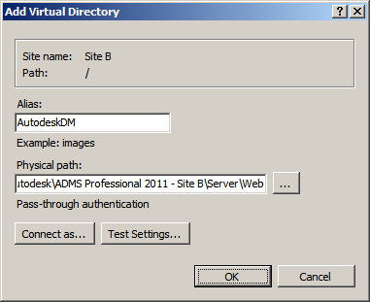
- Select the Services under AutodeskDM, right-click and select ‘Convert to Application’
  - Set the Application pool to Classic .NET.
Validation:
In the IIS Manager, view the content of the new Services folder. Select AdminService.asmx, right-click and select Browse. Your web browser should start up with a listing of functions. Ex. AddGroup, AddGroupRole, etc.
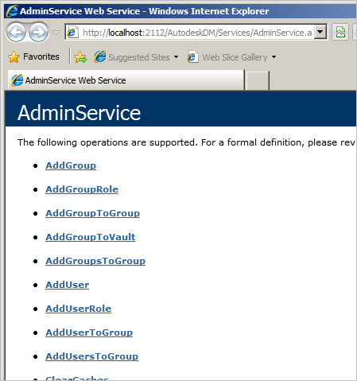

Changing the .config files
- Go to your FileStore location in Windows. Ex. C:\ProgramData\Autodesk\VaultServer\FileStore
- Create a second FileStore folder next to the first one. Ex. C:\ProgramData\Autodesk\VaultServer\FileStoreB
- Create a second Indexes folder too
- Go to Site B’s Server\Web\Services folder and open web.config in a text editor.
  - Replace all FileStore path references to FileStoreB
  - Replace all Indexes references to IndexesB
  - Find the <database> section and change the <server> value property to “(local)”
  - Find the <connectivity.web> section and change the <server> port to 2112 and website to “Site B”
  - Save and exit
- Go to Site B’s ADMS Console folder and open Connectivity.ADMSConsole.exe.Config in a text editor
  - In the <appSettings> section, change the webservicePath to the path to the corresponding Site B path.
  - In the <connectivity.vaultmanager> section, change the PORT to 2112.
  - Save and exit

Initializing the second database
- Launch Connectivity.ADMSConsole.exe from Site B’s ADMS Console folder.
- If you set up your config files properly, it should complain about there being no databases. Then show an empty application.
- Under the Tools menu, select Create Master Vault
- Enter your sa password when prompted.
- After a while it should prompt your for an Administrator login.
- Click OK and you should see filled in data for the application’s frames.
- Create a new Vault, which I will call “Vault”. The default file store location should be pointing to FileStoreB.
Add Vault data
- Open up the Vault Explorer. Log in to Site B. You do this by including the port number on the Server section of the login. Ex. Localhost:2112
- You should see an empty vault. If you see the file you upload to Site A, then something is wrong.
- Add a new file. It doesn’t need to be a complex file or anything, but it is something that you are able to view. So a TXT or JPG file is ideal. Do not upload the same file that you uploaded to the other site.
- Test out any other features if you want.
- Exit Vault Explorer.

Where we are at
Now we have 2 server installs running on the same machine. However they are independent servers. The next step is to set up replication.
We don’t need 2 clients. The existing client install can be used to connect to both servers.

Here is a recap of the setup so far. If you have different settings, you might want to create a grid of your own.
 | Site A | Site B
ADMS Folder | ADMS Professional 2011 | ADMS Professional 2011 - Site B
Port | 80 | 2112
DB Instance | localhost\AUTODESKVAULT | localhost
FileStore folder | Filestore | FilestoreB
Replication Type | Subscriber | Publisher
The part in red means we haven’t set that piece yet.

Clearing out Site A
We need to remove the existing data on site A, so that site B can replicate its data to site A.
- From the Windows command line, run “iisreset /stop”. This will shut down any connections to the Vault databases.
- Open SQL Manager and log in to the AUTODESKVAULT instance.
- Delete the Vault database.
- Delete the KnowledgeVaultMaster database.
- From the Windows command line, run “iisreset /start”.
Starting Replication
- Create a Windows folder for sharing data between the sites. Ex. c:\share
- Share up the folder for network sharing. To make things easier for testing, I suggest giving everybody full permissions.
- Start up Site B’s ADMS console.
- Right-click on the Workgroups item and select “Enable Workgroup Replication”
- Fill in the required data and click OK.
- Wait for operation to complete.
- Right-click on the Workgroups item and select “Add Workgroup”.
- Fill out the information for connecting to Site A.
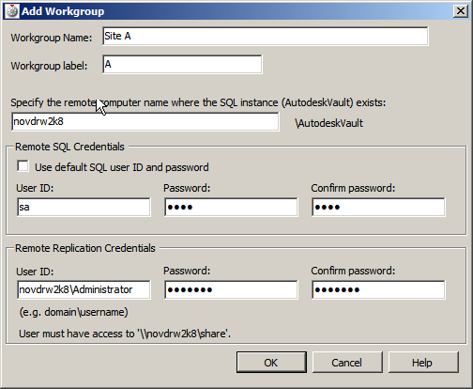
- Click OK.
- Wait for replication to complete.
- Right-click Vault and select “Manage Replication”.
- Move Site A into the Replicated box and click OK.
- Enter the credentials and click OK.
- Wait for replication to complete. The Vault will be disabled on site A during the initial sync.
Validation:
Open SQL Manager and check the AUTODESKVAULT instance. It should have KnowledgeVaultMaster and Vault databases.
Open Vault Explorer and sign in to site A (port 80). You should be able to log in and see the file uploaded to site B. Open the file to insure that download works and that the file contents are correct. The file should be locked, since site B is the owner.

Conclusion:
Congratulations, you now have a replicated Vault environment. Now you can test out your customizations and workflows in a replicated environment. If you are in a virtual image, I recommend saving a snapshot so that you don’t have to repeat these steps in the future.

